Jonathan Rile
Partner: Alexander Botten
701085173
CpE 311 – Wednesday 5-7:50
3/5/14

Lab 9: Software Interrupts using DEBUG

Introduction
The purpose of this lab was to have us learn how interrupts in software and interrupt service routines function within DOS.

Exercise 1: Activating the Interrupt Service Routine using INT

Experiment
For this experiment, we were to active an interrupt by calling the INT instruction along with it’s Interrupt Vector Number. To do this, we started up DEBUG as we have done in previous labs, and assembled the following code to offset 100.
int 0
int 3

Results/Questions
The program ran, and interrupt 0 and 3 executed.
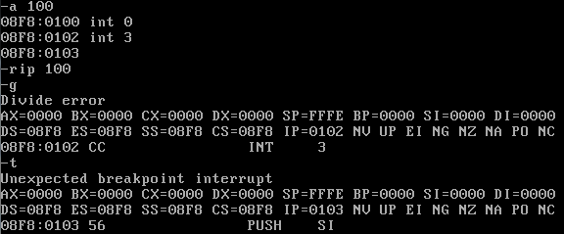
- Explain what “INT 0” does?
Vector 0: Divide-error
- Explain what “INT 3” does?
Vector 3: Breakpoint

Exercise 2: Triggering a divide-by-zero error

Experiment
For this experiment, we were to trigger an actual divide-by-zero error by dividing by zero rather than calling Interrupt 0.
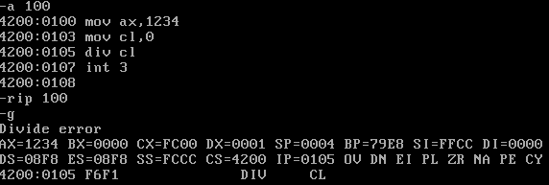

Results
The program gave us a divide error as expected.

Exercise 3: Executing INT 0 by directly running its ISR

Experiment
For this exercise, we wanted to execute INT 0 by finding it’s base and offset addresses, loading them into CS and IP, and then executing the ISR.
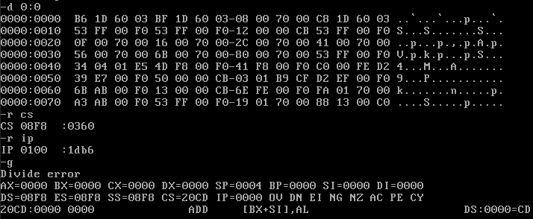

Results
We loaded the correct values and Interrupt 0 was called as expected.

Exercise 4: Changing the response to INT 0 by re-writing its ISR

Experiment
In this experiment, we wanted to overwrite the response in the ISR for interrupt 0. To do this, we assembled our own little program in offset 100, changed the address of the ISR corresponding to INT 0 to be CS:0100, and then tested it with another small program. 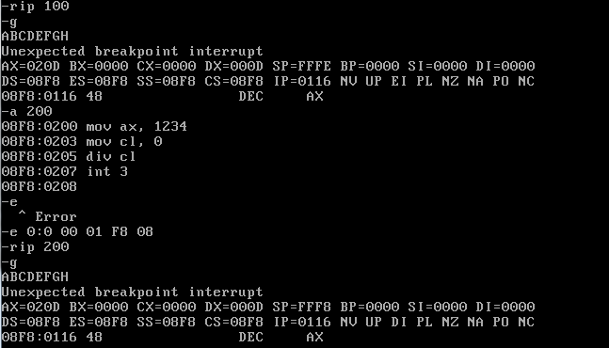

Results/Questions
The program ran as expected when we tested the interrupt.
What was the output? The program looped and printed ABCDEFGH (the value in DL that was incremented) and then a line break.

Exercise 5: Questions
- What are the differences between an Interrupt Service Routine (ISR) and a normal subroutine? Specifically: How does the system respond to an ISR? How does the system respond to a normal subroutine?
A subroutine runs when it is called, whereas an ISR runs when an interrupt is generated. You should know when a subroutine is called, but you may not know when an ISR will be called.
- What is a Hardware Interrupt? Provide an example of its use.
A hardware interrupt is a signal that something has happened with the hardware that the computer should know about, for example, a key has been pressed on a keyboard.
- A special type of Hardware Interrupts is the non-maskable interrupt (NMI). How is NMI different from other hardware interrupts?
A NMI is used for urgent events that cannot be ignored, such as system failure.

Conclusion
This lab really illustrates how we can alter the ISR to function as we need it to. I believe this will be useful in the future, in case we ever need to create our own interrupt.

